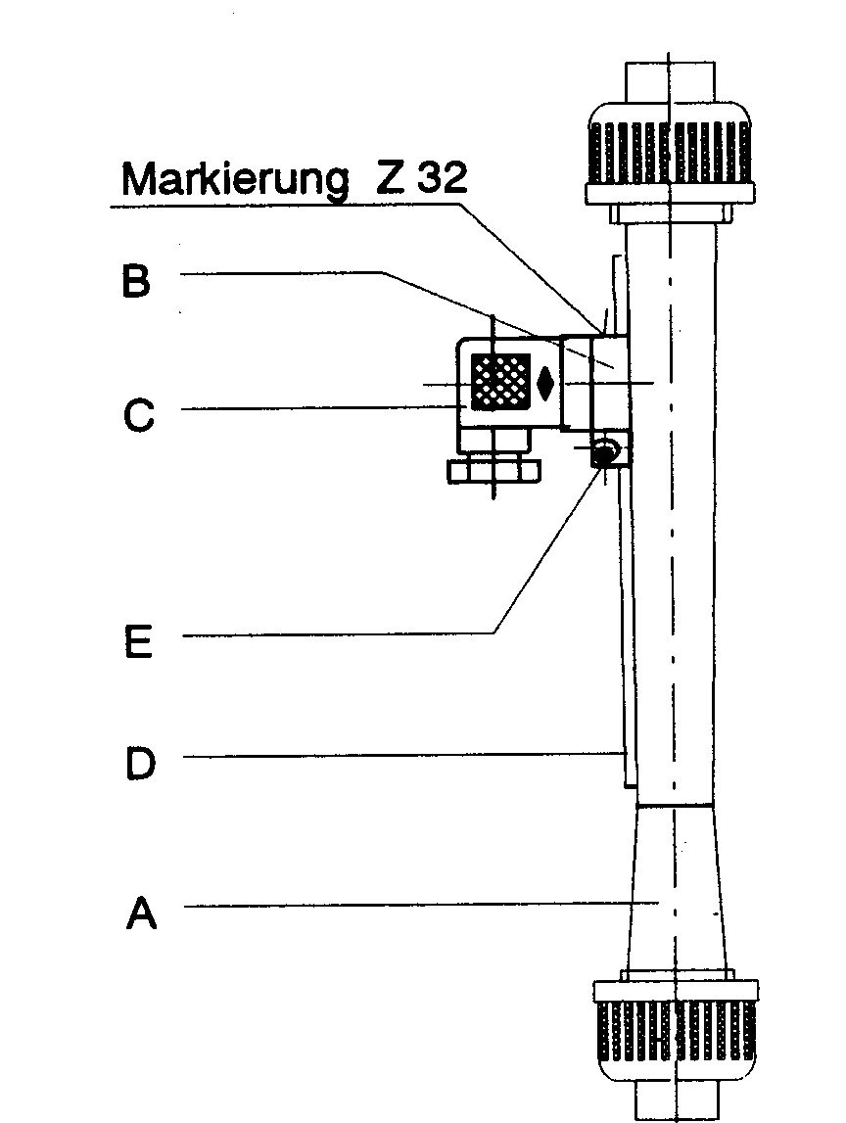

Limit switches Z31 & Z32
for flow-meter M23
Functional parts:

A) flow-meter M23 with magnetic float

B) limit switch Z31 or Z32

C) connector for electrical wiring

D) dovetail to mount Z31 or Z32

E) clamping screw to hold the limit switch in position.
marking Z32

Limit switch Z31 mono-stable:
The limit switch can be positioned anywhere along the M23. When the mono-stable magnetic float reaches that position, the limit switch will close and cause a switching action, The limit switch stays closed as long as the magnetic flost is near it. When the float moves above or below the limit switch, the Z31 opens.

Switching States:

float | limit switch
over the contact | open
level with the contact | close
below the contact | open

Limit switch Z32 bi-stable
Again, any position on the M23 can be chosen. Compared to the Z31, the Z32 will remain in its switched state, even if the float moves above or below the limit switch. When the float passes the limit switch again, it reverts back to its initial state. Depending on the direction of installation, the Z32 will open or close. A marking on the housing allows to choose the function: (see above sketch) marker upward = contact closes , marker downwards = contact opens

Switching status
 | Float | Limit switch
marking above | above the limit switch | close
 | below the limit switch | open
marking below | above the limit switch | open
 | below the limit switch | close

Attention! limit switch Z31 = flow-meter M23 with monostable float
limit switch Z32 = flow-meter M23 with bistable float

Technical Datas:

turn-on voltage | max. 230 V~
breaking capacity | max. 10 W / 12 VA
circuit power | max. 0.5 A
volume-resistance | < 200 m Ohm
direct-current resistivity | > 1011 Ohm
allowed ambient temperature | 0 - + 55 °C
protection | DIN 40050 – IP 65
on- & off-hesteresis Z31 | 1 – 2 mm float-way
entirehysteresis at overdrive of Z31 | 30 – 35 mm
on- & off-hesteresis Z32 | 3 – 12 mm float-way
dimenions | 49 x 30 x 47
weight with plug | 40 g

Attention!!
The figures of the turn-on voltage, breaking capacity and the circuit power may not be higher, not even for a minimal time, than the stated figures otherwise the reed-contact can be damaged.

Assemble-Guide

- put the limit switch (B) on the dovetail (D) of the flow-meter (A)
- set the desired value and fix it with the locking screw (E)
- put off and wire the plug (C)
- screw the plug with insert seal

part-nos:

Z31 monostable | 73.660
Z32 bistable | 73.659

Connection allocation Z31 / Z32
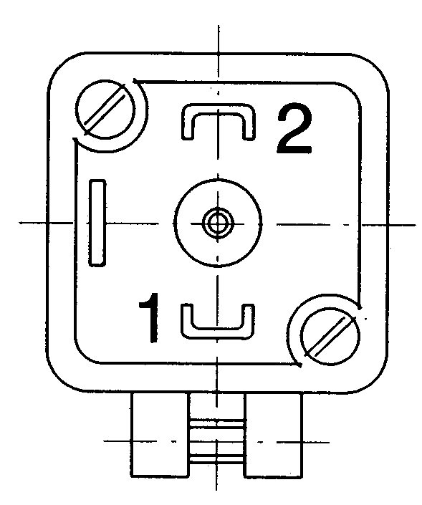
Limit switch without plug (above view)

